Hyperlink Dash Report — User Manual (Windows Executable)
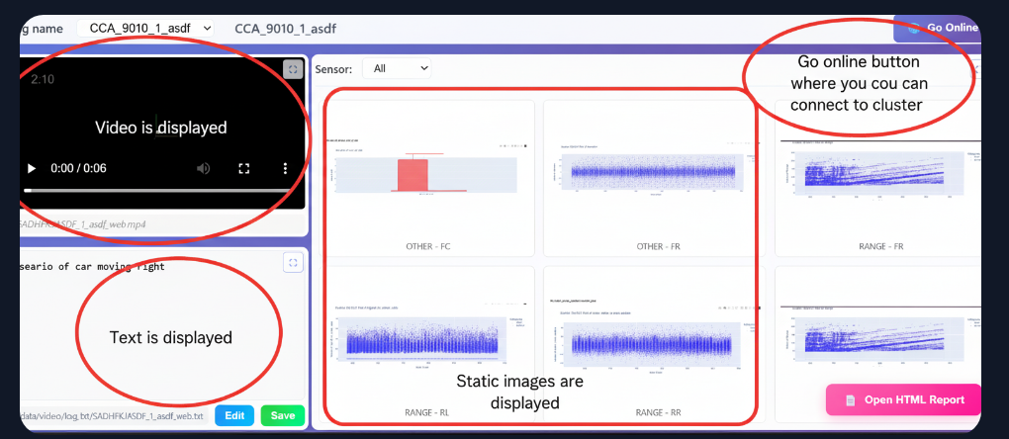
Applies to:
• Online Mode (log_viewer_online.exe) — starts a local web server to view logs in a browser.
• Offline Mode (log_viewer_offline.exe) — generates an HTML output from given input folders (no web server).

1) OVERVIEW
• Purpose: View and analyze HTML/video logs. Online Mode serves a browser UI from a local server. Offline Mode produces a report from inputs.
• Static UI is NOT bundled inside the .exe. You MUST provide a folder named "static" beside the .exe.
• User data (downloaded/imported HTML & video) is stored in ".cache_html" inside the current working directory (CWD) you launch the .exe from.
• If "static" is missing, the console prints "HTML root: Not found" and "/" returns 404.

2) REQUIREMENTS
• Windows 10/11 (x64).
• The correct .exe:
- Online: log_viewer_online.exe
- Offline: log_viewer_offline.exe
• A complete "static" folder placed BESIDE the .exe (same directory).
• Optional: sample HTML/video inputs if you want to pre-seed the cache.

3) RECOMMENDED FOLDER LAYOUT
Create:
C:\Tools\LogViewer\
Place files:
C:\Tools\LogViewer\log_viewer_online.exe
C:\Tools\LogViewer\static\index.html
C:\Tools\LogViewer\static\assets\css\...
C:\Tools\LogViewer\static\assets\js\...
C:\Tools\LogViewer\static\assets\img\...

4) RUNNING THE EXECUTABLES

4.1 ONLINE MODE (log_viewer_online.exe)
Steps:
1) Open Command Prompt or PowerShell.
2) Change directory to the folder that contains the .exe and static:
cd /d C:\Tools\LogViewer
3) Run:
log_viewer_online.exe --serve
4) On success, expect:
HTML root: C:\Tools\LogViewer\static
Running on http://127.0.0.1:5000
5) Open the printed address in your browser.

Under the hood:
• The app resolves "static" relative to the current working directory (CWD).
• The app uses/creates ".cache_html" in the SAME CWD.

4.2 OFFLINE MODE (log_viewer_offline.exe)
Command format:
log_viewer_offline.exe "<html_input_folder>" "<video_input_folder>" "<output_html_file>"
Example:
cd /d C:\Tools\LogViewer
log_viewer_offline.exe "C:\Data\logs_html" "C:\Data\logs_video" "C:\Reports\viewer.html"
Notes:
• "static" must still be beside the .exe because the generated HTML may reference UI assets (images/styles/scripts).

5) STATIC FOLDER — PLACEMENT AND IMAGES
Rules:
• Folder name must be "static" (lowercase).
• It must sit BESIDE the .exe (same directory).
• It must contain your UI entry (index.html) and any images used by the UI (e.g., static\assets\img\...).
Example layout:
static\
index.html
assets\
css\*.css
js\*.js
img\
logo.png
play.svg
spinner.gif
thumbnails\
*.jpg/*.png

Validation checklist:
• C:\Tools\LogViewer\static\index.html exists.
• UI images under static\assets\img\... exist.
• You launched the .exe from the folder that contains "static".

Common error if static is wrong:
• Console prints: "HTML root: Not found"
• Browser shows 404 at "/"
Fix:
• Put "static" beside the .exe and re-run from that folder.

6) CACHE BEHAVIOR (.cache_html)
• Created/used in the CURRENT WORKING DIRECTORY (CWD) from which you launch the .exe.
• Stores user-provided or downloaded HTML/video.
• Launching via a shortcut? Check the shortcut’s "Start in" — that becomes the CWD. If it points elsewhere, ".cache_html" will be created there.
Optional pre-seed:
C:\Tools\LogViewer\.cache_html\
html\...
video\...

7) IF PORT 5000 IS NOT FREE (ONLINE MODE)
Symptoms:
• The server fails to bind to 127.0.0.1:5000 or prints "Address already in use".

Option A — Run on a different port (preferred):
log_viewer_online.exe --serve --port 5100
Then open:
http://127.0.0.1:5100
If "--port" is NOT supported, try environment variable:
set PORT=5100
log_viewer_online.exe --serve

Option B — Free port 5000 and retry:
netstat -ano | findstr :5000
taskkill /PID <PID> /F
log_viewer_online.exe --serve

8) TROUBLESHOOTING
• "HTML root: Not found" on startup
- Ensure static\index.html exists beside the .exe.
- Ensure you launched the .exe FROM THAT FOLDER (CWD matters).
• Server runs but browser returns 404 at "/"
- Check console logs; confirm the printed "HTML root" path points to your static folder.
- Ensure static\index.html exists and routes match.
• ".cache_html" never created
- The app creates the folder when needed (e.g., on importing/downloading data).
- Try adding data via the UI or create ".cache_html" manually.
• Images not visible in the UI
- Confirm images physically exist under static\assets\img\... and your HTML paths are correct.
• Running via a shortcut
- Ensure the shortcut "Start in" points to the .exe folder; otherwise ".cache_html" may be created elsewhere.

9) COPY-ALL COMMANDS (ONE BLOCK)

:: ===== Set working folder =====
cd /d C:\Tools\LogViewer

:: ===== Run Online (default port) =====
log_viewer_online.exe --serve

:: ===== Run Online (custom port 5100) =====
log_viewer_online.exe --serve --port 5100
:: or
set PORT=5100
log_viewer_online.exe --serve

:: ===== Check who uses port 5000 =====
netstat -ano | findstr :5000

:: ===== Kill by PID (replace <PID>) =====
taskkill /PID <PID> /F

:: ===== Run Offline (example) =====
log_viewer_offline.exe "C:\Data\logs_html" "C:\Data\logs_video" "C:\Reports\viewer.html"

10) SUPPORT
• Jira: HZP (e.g., HZP-764)
• Owner: Krishnakumar Bhat (GET | Radar Simulations)
• Email: krishnakumar.balachandra.bhat@aptiv.com

